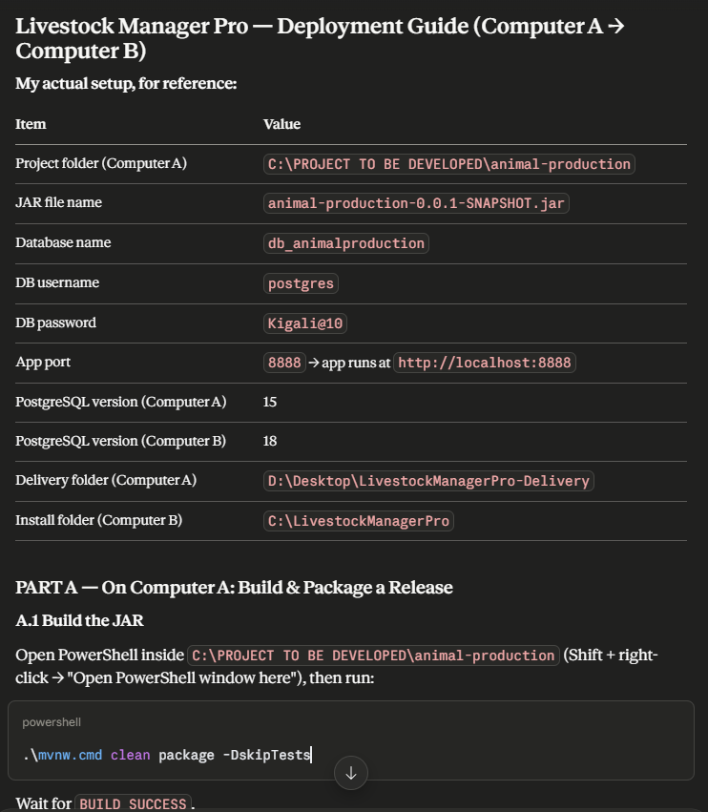
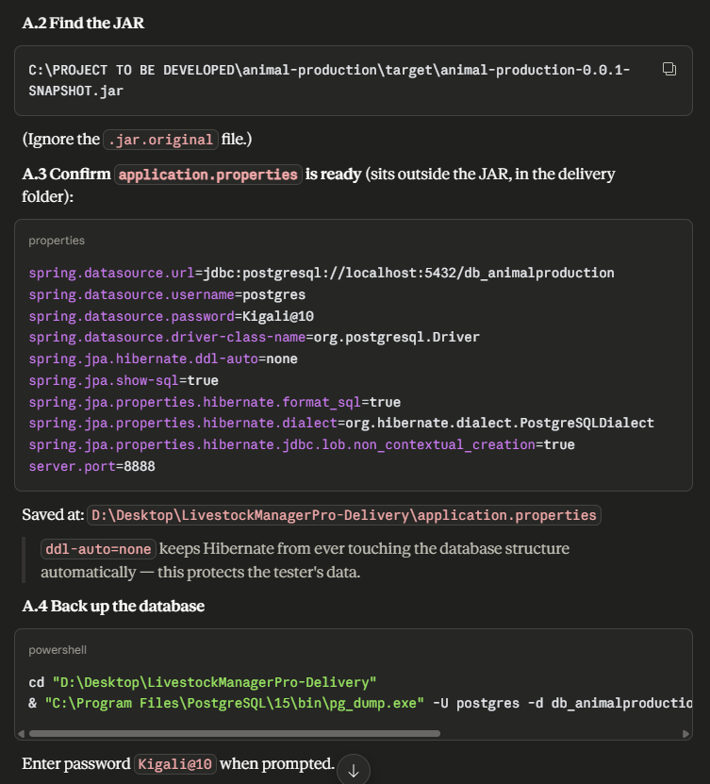
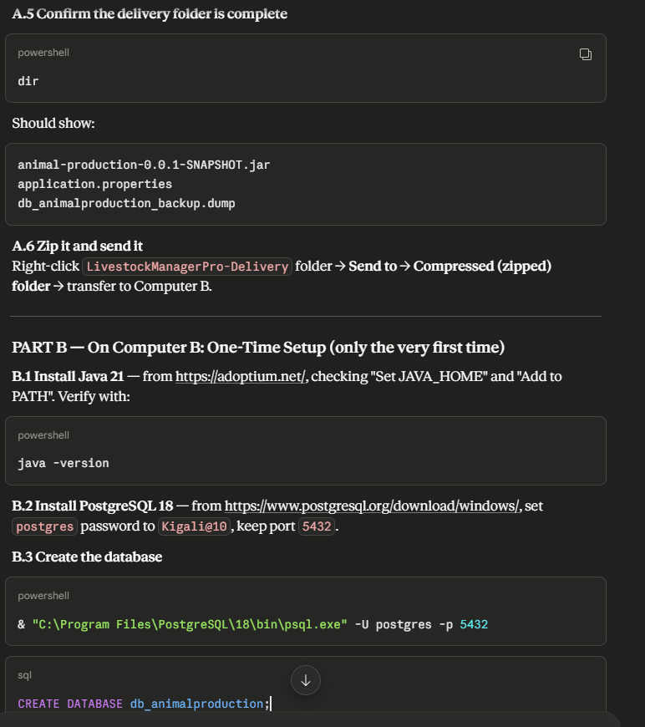
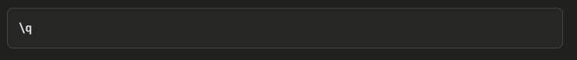
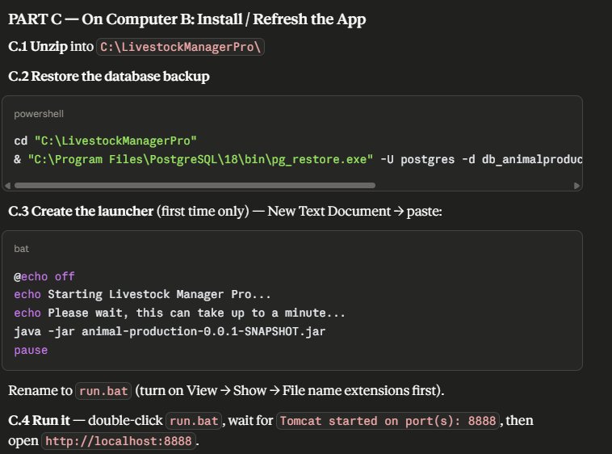
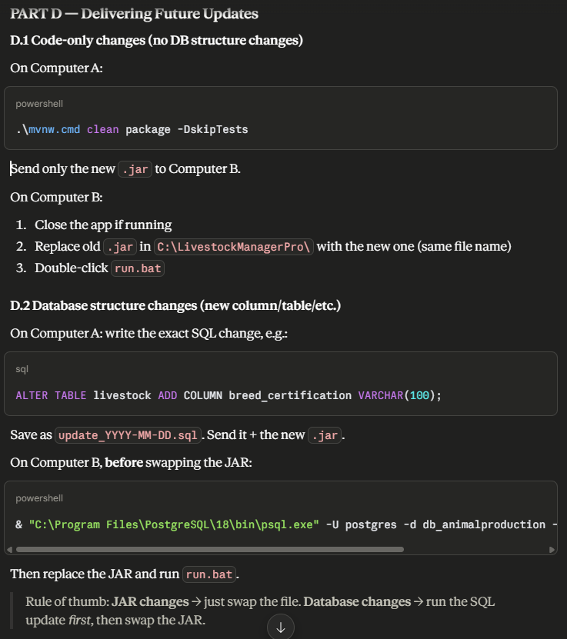
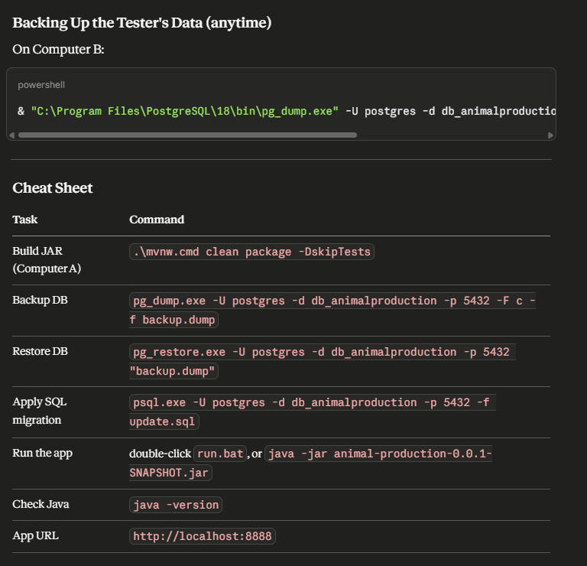
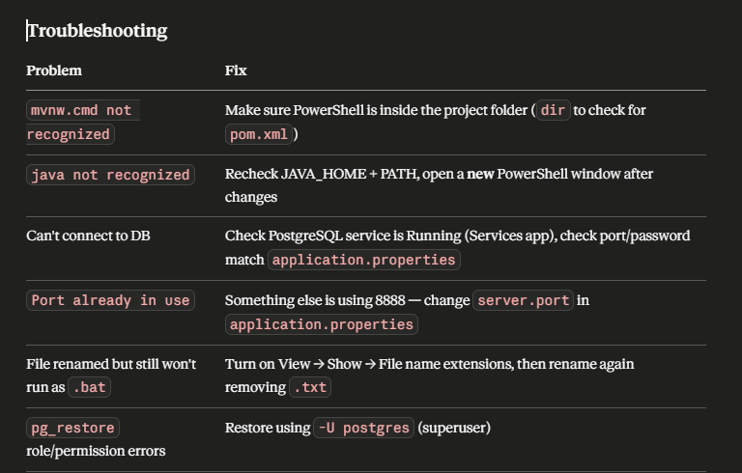

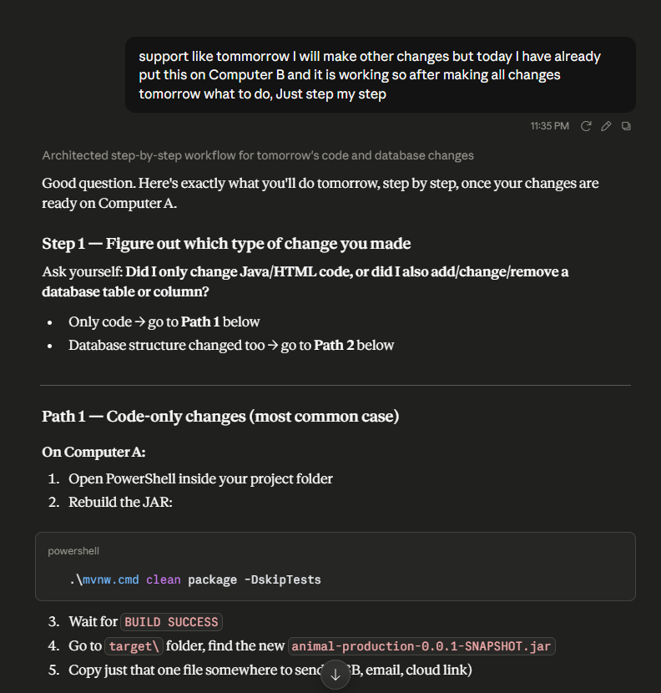
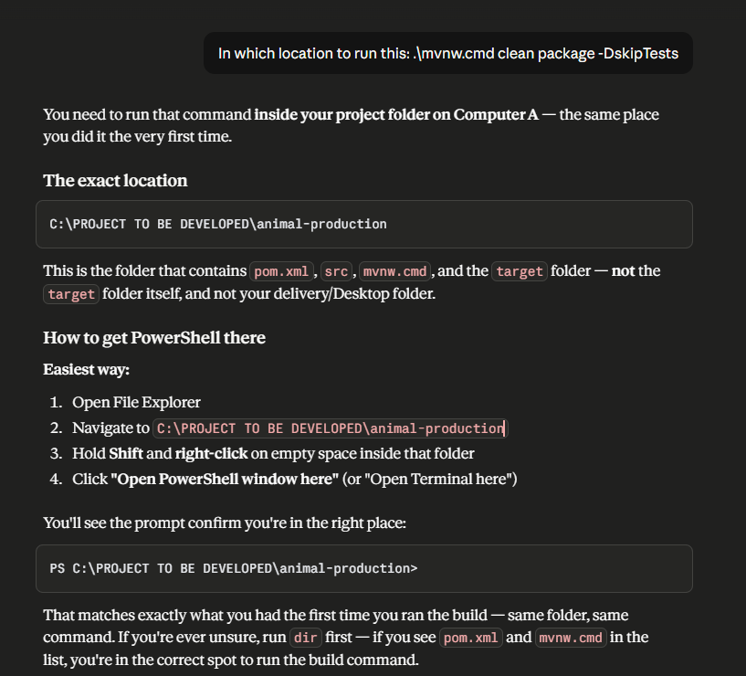

NEW STEP:
PART A: On Computer A (your PC)
Step 1. Open PowerShell in your project folder
- Open File Explorer and go to C:\PROJECT TO BE DEVELOPED\animal-production.
- Hold Shift, right-click on an empty space, and choose Open PowerShell window here.
- Type dir. You must see pom.xml, mvnw.cmd and src. If not, you are in the wrong folder.
Step 2. Build the JAR
.\mvnw.cmd clean package -DskipTests
Wait until you see BUILD SUCCESS.
Step 3. Create the delivery folder and copy the JAR
- Create the folder D:\Desktop\LivestockManagerPro-Delivery.
- Copy target\animal-production-0.0.1-SNAPSHOT.jar into it. Ignore the .jar.original file.
Step 4. Create application.properties in the delivery folder
Make a new text file with this exact name and paste:
spring.datasource.url=jdbc:postgresql://localhost:5432/db_animalproduction
spring.datasource.username=livestock_app
spring.datasource.password=YourStrongPassword
spring.datasource.driver-class-name=org.postgresql.Driver
spring.jpa.hibernate.ddl-auto=none
spring.jpa.show-sql=false
spring.jpa.properties.hibernate.dialect=org.hibernate.dialect.PostgreSQLDialect
spring.jpa.properties.hibernate.jdbc.lob.non_contextual_creation=true
server.port=8888
logging.file.name=logs/app.log
Step 5. Create run.bat in the delivery folder
Make a new text file, paste this, and save it as run.bat:
@echo off
cd /d "%~dp0"
echo Starting Livestock Manager Pro...
echo Please wait, this can take up to a minute...
java -jar animal-production-0.0.1-SNAPSHOT.jar
pause
If it becomes run.bat.txt, in File Explorer go to View → Show → File name extensions and rename it.
Step 6. Create backup.bat in the delivery folder
@echo off
cd /d "%~dp0"
if not exist backups mkdir backups
set PGPASSWORD=YourStrongPassword
for /f %%i in ('powershell -NoProfile -Command "Get-Date -Format yyyy-MM-dd_HHmm"') do set STAMP=%%i
"C:\Program Files\PostgreSQL\18\bin\pg_dump.exe" -U livestock_app -h localhost -p 5432 -F c -d db_animalproduction -f "backups\db_%STAMP%.dump"
forfiles /p "backups" /m *.dump /d -30 /c "cmd /c del @path" 2>nul
echo Backup finished.
Step 7. Back up your database
In PowerShell:
cd "D:\Desktop\LivestockManagerPro-Delivery"
& "C:\Program Files\PostgreSQL\15\bin\pg_dump.exe" -U postgres -p 5432 -F c -d db_animalproduction -f db_animalproduction_backup.dump
Type your Computer A postgres password (nothing shows while typing, that's normal).
Step 8. Check and send
Run dir. You should see 5 files: the JAR, application.properties, run.bat, backup.bat, and db_animalproduction_backup.dump.
Then right-click the folder → Send to → Compressed (zipped) folder, and move the zip to Computer B.

PART B: On Computer B (one time only)
Step 1. Install Java 21
- Download Temurin 21 from https://adoptium.net/ and install it.
- Tick Set JAVA_HOME and Add to PATH.
- Open a new PowerShell and run java -version. It should say 21.
Step 2. Install PostgreSQL 18
- Download it from https://www.postgresql.org/download/windows/.
- Set a password for postgres and write it down. Keep port 5432.
Step 3. Create the app user and empty database
& "C:\Program Files\PostgreSQL\18\bin\psql.exe" -U postgres -p 5432
Enter the postgres password. At the postgres=# prompt, type these one at a time:
CREATE ROLE livestock_app WITH LOGIN PASSWORD 'YourStrongPassword';
CREATE DATABASE db_animalproduction OWNER livestock_app TEMPLATE template0 ENCODING 'UTF8';
\q

PART C: On Computer B (install the app, first time only)
Step 1. Unzip
Extract the zip into C:\LivestockManagerPro. Check the 5 files are directly inside that folder, not inside another subfolder.
Step 2. Restore the database (do this ONCE only)
cd "C:\LivestockManagerPro"
& "C:\Program Files\PostgreSQL\18\bin\pg_restore.exe" -U postgres -p 5432 -d db_animalproduction --no-owner --role=livestock_app "db_animalproduction_backup.dump"
Enter the postgres password.
Never run this step again after the user has started entering real data. It would overwrite their work.
Step 3. Run the app
Double-click run.bat. Wait for Tomcat started on port(s): 8888, then open http://localhost:8888 in a browser. Don't close the black window while using the app.
Step 4. Make it easier for the user
- Right-click run.bat → Create shortcut, and move the shortcut to the Desktop.
- Right-click the shortcut → Properties → set Run: Minimized → OK.
Step 5. Schedule daily backups
Open PowerShell as administrator and run:
schtasks /create /tn "LivestockBackup" /tr "C:\LivestockManagerPro\backup.bat" /sc daily /st 18:00
Test it by double-clicking backup.bat. A file should appear in C:\LivestockManagerPro\backups.

PART D: Sending updates later
Case 1: only code changed (most common)
On Computer A:
- Open PowerShell in the project folder (the one with pom.xml).
- Run .\mvnw.cmd clean package -DskipTests and wait for BUILD SUCCESS.
- Send only the new JAR from the target folder.
On Computer B:
- Close the app.
- Double-click backup.bat (safety backup).
- Rename the old JAR to animal-production-0.0.1-SNAPSHOT.jar.old.
- Copy the new JAR in with the same name.
- Double-click run.bat.
If something goes wrong, delete the new JAR and rename the .old one back.
Case 2: a database table or column also changed
On Computer A: write the change in a file named like update_2026-10-02.sql, for example:
ALTER TABLE livestock ADD COLUMN breed_certification VARCHAR(100);
Build the new JAR and send both files.
On Computer B, in this order:
- Close the app.
- Double-click backup.bat.
- Run the SQL:
cd "C:\LivestockManagerPro"
& "C:\Program Files\PostgreSQL\18\bin\psql.exe" -U livestock_app -p 5432 -d db_animalproduction -v ON_ERROR_STOP=1 -f "update_2026-10-02.sql"
- Swap the JAR (as in Case 1) and run run.bat.
Rule to remember: code change → swap the JAR. Database change → run the SQL first, then swap the JAR. Never restore the full dump again.

Quick fixes
Problem | Fix
mvnw.cmd not recognized | You're not in the project folder. Run dir and look for pom.xml.
java not recognized | Open a new PowerShell window.
Can't connect to database | Check the PostgreSQL service is running, and the password in application.properties is correct.
Port 8888 already in use | Close the other app, or change server.port.
run.bat won't run | It's really run.bat.txt. Show file extensions and rename.
If any step is still unclear, tell me its number (for example "Part C, Step 2") and I'll explain it in more detail.

